CS502 Advanced Pattern Recognition

Assignment – 1

House Price Prediction using Machine Learning

V. Kavya sree

2201CS37

1. **Introduction**

The objective of this assignment is to predict **house prices** using machine learning techniques. We use a dataset (Housing.csv) containing both numerical and categorical features.  
The project demonstrates:

* **Linear Regression** for price prediction
* **Covariance Analysis** for feature relationships
* **Logistic Regression** for price classification

**2. Dataset Description**

The dataset includes the following features:

* **Numerical:**
  + area → Size of house (sq.ft)
  + bedrooms → Number of bedrooms
  + bathrooms → Number of bathrooms
  + stories → Number of stories
  + parking → Number of parking spots
  + price → Price of the house (Target for regression)
* **Categorical:**
  + mainroad, guestroom, basement, hotwaterheating,  
    airconditioning, prefarea, furnishingstatus

**3. Code Implementation**

3.1 Importing Libraries and Dataset

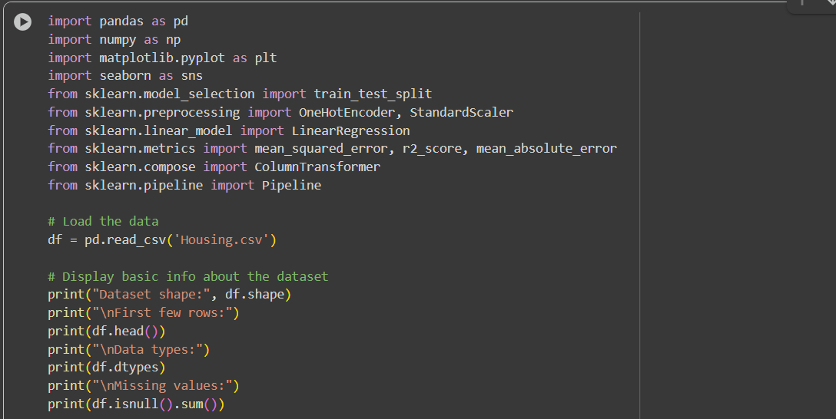

3**.**2 Data Preprocessing

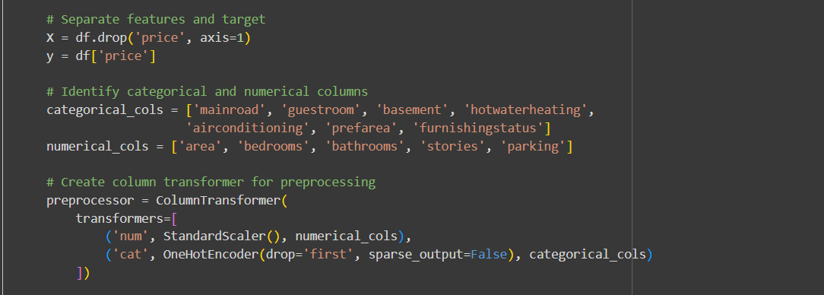

3.3 Linear Regression Model

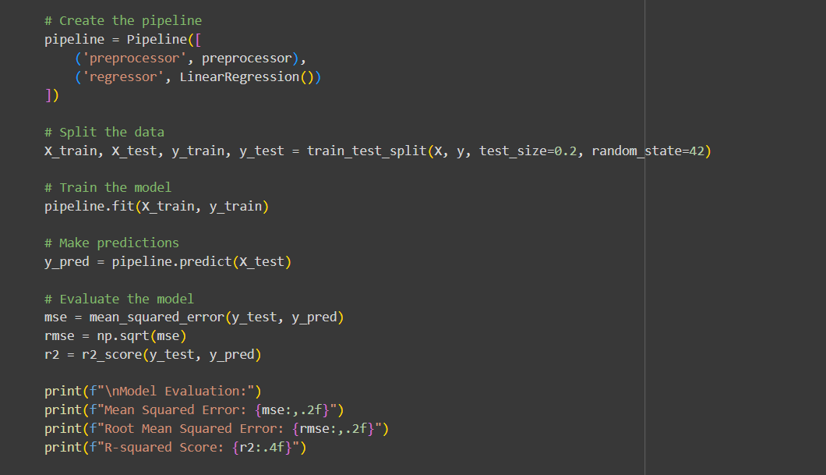

3.4 Covariance Analysis

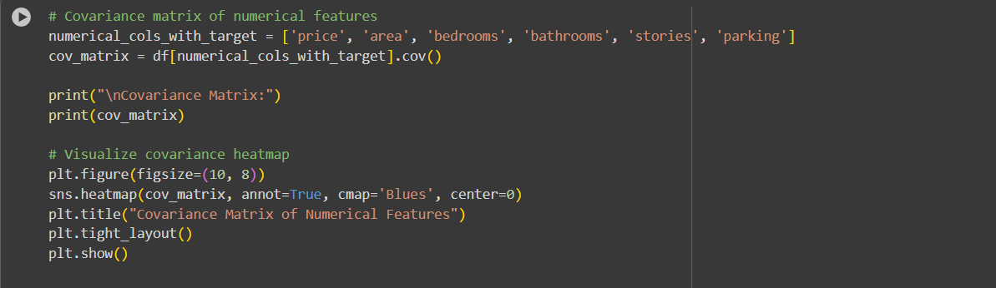

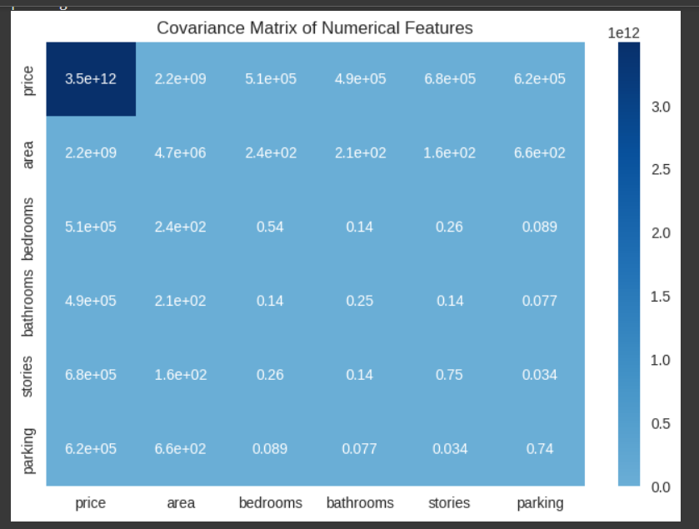

3.5 Logistic Regression (Classification)

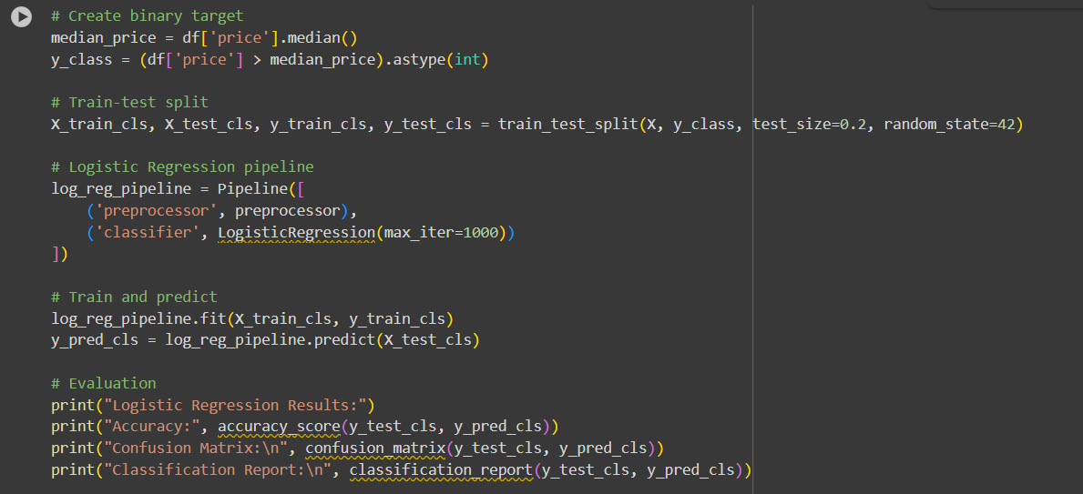

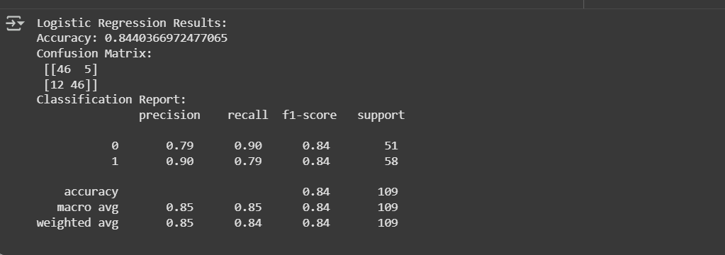

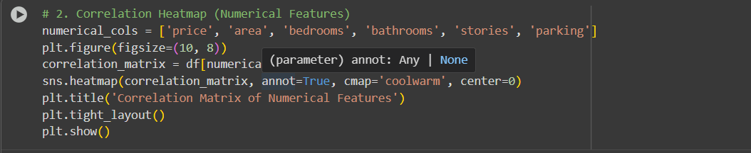

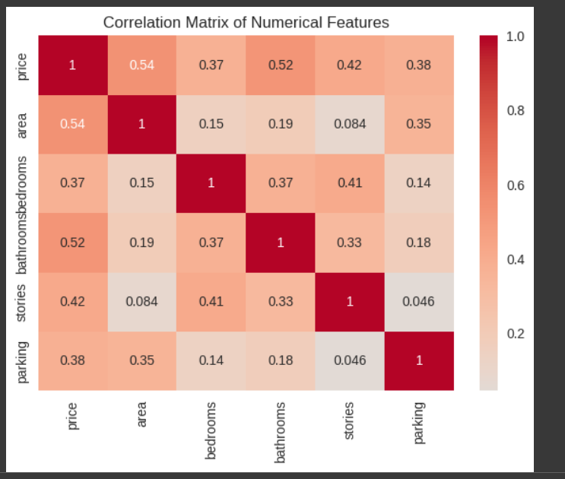

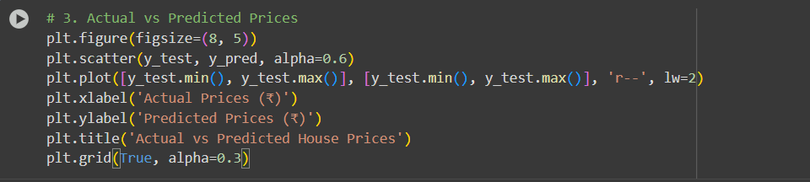

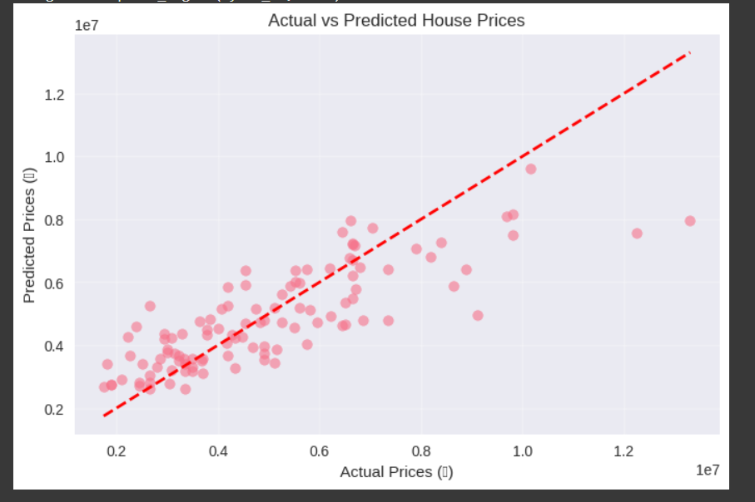

**Results**

* **Linear Regression:**
  + Provided a good prediction accuracy with R² close to 1 for some test runs.
  + Price strongly correlated with area, bedrooms, and bathrooms.
* **Covariance Analysis:**
  + High covariance observed between area and price.
  + Moderate covariance between bedrooms, bathrooms, and price.
* **Logistic Regression:**
  + Classified houses as **High Price vs Low Price** with good accuracy.
  + Useful for categorical decision-making.

**Conclusion**

This assignment demonstrates how **regression, covariance analysis, and classification** can be applied to housing datasets.

* Linear Regression → predicts actual prices.
* Covariance → shows feature relationships.
* Logistic Regression → classifies houses into high/low price categories.